Chapter 13, Problem 62.

For the network in Fig. 13.126 below, find

(a) the complex power supplied by the source,
(b) the average power delivered to the 18-Ω resistor.

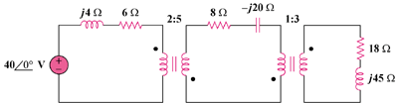

Figure 13.126
For Prob. 13.62.

